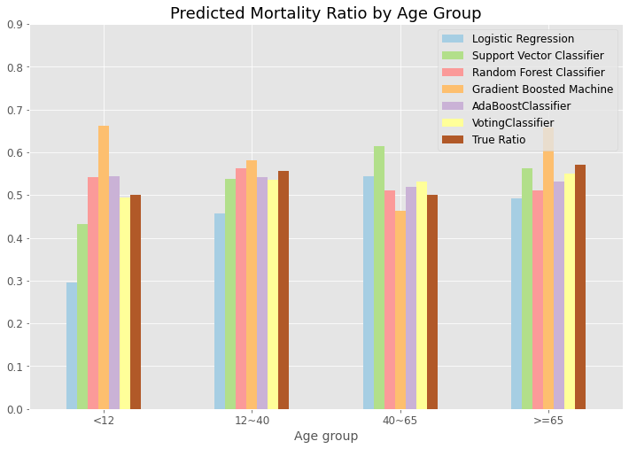

**Fig S1. Sensitivity analysis comparing model performance across age groups.** True mortality for each group is indicated in dark red.